|  |  |  |  |  |  |  |  |  |  |  |  |
| --- | --- | --- | --- | --- | --- | --- | --- | --- | --- | --- | --- |
| **Assignment Cover Sheet** | | | | | | | | C:\Users\qualityassurancemgr\Downloads\UCC LOGO.jpg | | | |
|  | **STUDENT DETAILS** | | | | | | | | | | | |
|  | Assignment**:** Individual Assignment:  Group Assignment: | | | | | | | | | | | |
|  | Names | | | ID#s | | | Programme/Department | | | | | |
|  | Alicia Allwood | | | 20183747 | | | BSc in Information Technology | | | | | |
|  | Shakira Brydson | | | 20042565 | | | BSc in Information Technology | | | | | |
|  | Shanique Davis | | | 20171500 | | | BSc in Information Technology | | | | | |
|  | Maurice Gordon | | | 20113550 | | | BSc in Information Technology | | | | | |
|  | Sheryl Robinson | | | 20142027 | | | BSc in Business Administration | | | | | |
|  | **COURSE DETAILS** | | | | | | | | | | | |
|  | Course Code*: (eg. HRM306)*  ITT305 | | | | | | Course Title: *(eg. Human Relations in Organisation)*  Systems Analysis and Design II | | | | | |
|  | Lecturer: *(eg. First Name Last name)*  Sydia Brown | | | | | | | | | | | |
|  | **ASSIGNMENT DETAILS** | | | | | | | | | | | |
|  | Assignment title**:** *(Title of the essay, project or the question)*  Final Project Report | | | | | | | | | | | |
|  | Word Count/Length: *(If required)* | | | | | | Submission Due: *(day, month year)*  30, April 2021 | | | | | |
|  | **DECLARATION:** | | | | | | | | | | | |
|  | I/we certify that I have read and understood the implications of the Academic Integrity and Copyright guidelines on my Course Outline. I certify that the assignment submitted is my own work and that all materials used from reference sources have been fully acknowledged. Click to agree | | | | | | | | | | | |
|  | **For Instructors Only**  **Course Learning Outcomes (CLO)** | | | | | | | | | | | |
|  | **Question #** | **CLO 1** | **CLO 2** | | **CLO 3** | **CLO 4** | **CLO 5** | | **CLO 6** | **Lecturer’s Total** | * **Vetter’s or** * **2nd Marker’s Total** | |
|  |  |  |  | |  |  |  | |  |  |  | |
|  |  |  |  | |  |  |  | |  |  |  | |
|  |  |  |  | |  |  |  | |  |  |  | |
|  |  |  |  | |  |  |  | |  |  |  | |
|  | **Total** |  |  | |  |  |  | |  |  |  | |
|  | **Lecturer’s/Examiner’s Comments:** | | | | | | **Comments: 2nd Marker: [****] Vetter: []** | | | | | |
|  |  | | | | | |  | | | | | |
|  | **Name:**  **Signature: Date:** | | | | | | **Name:**  **Signature: Date:** | | | | | |

**EXECUTIVE SUMMARY**

Silver Cloud Financial Services (SCFS) was set up by a group of investors, with a mandate to provide affordable loan facilities to its shareholders who wish to buy, repair or improve on their properties, buy a car or an education loan. SCFS also provides personal loan financing for business ventures.

SCFS commenced its operation in September 2016 and has three (3) locations islandwide; St. Andrew, Portmore and St James. Customers wishing to access loans are required to visit a SCFS office to apply and submit a loan application, which is processed manually (See Process Description below).

An Online Loan Applications project will be initiated in June 2021, to automate and streamline loan applications and processing. The project is being undertaken in two phases. The first phase seeks to eliminate paper applications for loans. The second phase seeks to automate the applications processing and is expected to be implemented by September 26, 2022.

**TABLE OF CONTENTS**

**TITLES PAGES**

**EXECUTIVE SUMMARY** **2**

**1. INTRODUCTION** **4**

**2. BACKGROUND** **5**

2.1 Full Project scope (what’s included, what’s excluded) 5

**3. REQUIREMENTS** **9**

**3.1 Functional requirements (user & system) PHASE ONE** **9**

3.1 Functional requirements (user & system) PHASE TWO 14

3.2 Non-functional requirement (user & system) 16

**4. OPTIONS AND RECOMMENDATIONS** **18**

4.1 Comparison of package VS development (comparison matrix and text) 18

4.2 Recommendation 19

**5. PHYSICAL DESIGN** **20**

5.1 System reports & input forms 20

5.1.1 Silver Cloud Login Form 20

5.1.2 Silver Cloud Client Registration Form 21

5.2 System interfaces 23

5.3 System menu & control 23

5.4 Proposed architecture (data distribution, network layout, etc.) 24

5.5 Proposed platform (memory, disk space, operating system, peripherals, network, etc) 25

**Client Slide** **26**

**7. IMPLEMENTATION** **27**

7.1 Implementation plan (implementation method, schedule, data loading, training) 27

**APPENDICES** **27**

Project team structure and responsibilities 27

APA Referencing 27

Conclusion 27

# 

# 

# INTRODUCTION

Silver Cloud Financial Services is experiencing challenges with its core business operation that provides its customers with an effective and seamless loan process. The Customer Care Department monthly operational reports reflect numerous complaints from customers regarding the poor service received and the lengthy processing time to receive a loan. The Management Team met and ordered that an Online Loan Application Selection System (OLASS) be implemented to address the customer’s concerns and improve business efficiency, which will result in customer satisfaction and increase revenue.

The project will consist of two phases to manage the risks with implementation. The expected timeline for the project is 16 months. It is scheduled to commence in June 2021 and end September 2022. The estimated budget allocated to the project is $5,500,000.00.

# 

# 

# 2. BACKGROUND

## 2.1 Full Project scope (what’s included, what’s excluded)

CURRENT PROCESS DESCRIPTION

Customers wishing to apply for any loan benefit are required to collect a loan application form at any SCFS office and submit completed loan application along with all the required documentation.

The number of paper applications submitted for any particular loan can easily exceed 500 per week. Each application is assessed to determine:

i. whether the customer is eligible for the loan (eligibility)

ii. the maximum loan amount for which the customer can qualify (affordability).

This assessment is done by a team designated to

i. Sort the applications

ii. Review each application and determine eligible applicant

iii. Calculate the number of credit for each applicant

iv. Update the data from the applications into an excel spreadsheet

v. Verify the customer account information in the appropriate systems

vi. Queue and select applicants, in accordance with the business rules

The selection is based on a combination of factors including:

i. Customers with an account, one (1) year and olders

ii. The number of credits earned based on the Credit System, preferring the higher to the lower number.

Under the Credit system, credits are also awarded to customers based on the customer’s credit history, as well as their current income, as follows:

i. 100 credits if credit history is of good standings (which is awarded manually upon receipt of

the credit report)

iii. Credits are awarded based on the current weekly income, as under:

Weekly Income Credit Rating

$7,000.00 - $15,000.99 70

$15,001.00 - $25,000.99 80

$25,001.00 - $35,000.99 90

$35,001 and over 110

All loan are calculated at an interest rate of 12.5%, with a maximum tenure and loan amounts are as under:

Loan Type Loan Tenure Loan Amount (Max)

Mortgage Loan - buy 30 years $10,000,000.00

Mortgage Loan - repair or improve 20 years $ 2,500,000.00

Car Loan 10 years $ 2,500,000.00

Education Loan 5 years $ 1,500,000.00

Personal Loan 10 years $ 5,000,000.00

The excel database of all loan applications received, the listing of the proposed selectees, and the supporting documentation including the application forms are then forwarded to the Loan Audit Department for review and approval. Customers who are approved for the loan are then invited to an interview to complete the process.

PROJECT SCOPE

Activities to be undertaken pre implementation

* Accept loan applications online
* Determine eligibility
* Limited validation checks
* Calculate credits based on applicant current weekly income
* Approve/deny loan application
* Generate Reports

Activities to be undertaken post implementation

* Export data to Excel Format
* Send electronic notifications

PROJECT JUSTIFICATION

The implementation of an Online Loan Application Selection System (OLASS) will improve the level of efficiency for the SCFS loan processes. This will resolve the issues with customers’ complaints, lengthy loan sections and approval time, and also protect the company’s image.

**3. REQUIREMENTS**

## 3.1 Functional requirements (user & system) Pre implementation

|  |  |  |  |  |  |
| --- | --- | --- | --- | --- | --- |
| ID | RO1 | Status |  | Loan Type | All loans |
| Priority | 1 | Rationale |  | | |
| Description | The system shall include a user authorization procedure where users must identify themselves using a login name and password. Only users who are authorized in this way may access the system. | | | | |

|  |  |  |  |  |  |
| --- | --- | --- | --- | --- | --- |
| ID | RO2 | Source |  | Loan Type | All loans |
| Priority | 1 | Rationale | To eliminate paper applications, and to capture data at source | | |
| Description | The system shall allow the applicant to complete and submit a loan application for any loan type online. | | | | |

|  |  |  |  |  |  |
| --- | --- | --- | --- | --- | --- |
| ID | RO3 | Source |  | Loan Type | All loans |
| Priority | 1 | Rationale | To ensure that applications submitted are valid, thereby reducing the number of rejected loan applications. | | |
| Description | A loan applicant shall not be allowed to proceed to the next step if it fails to meet one or more of the eligibility criteria. | | | | |

## 

|  |  |  |  |  |  |
| --- | --- | --- | --- | --- | --- |
| ID | RO4 | Source |  | Loan Type | All loans |
| Priority | 1 | Rationale | To ensure that loan applications submitted are valid, thereby reducing the number of rejected applications. | | |
| Description | The system shall execute eligibility and validation checks and shall accept loan applications that meet the eligibility criteria. | | | | |

## 

|  |  |  |  |  |  |
| --- | --- | --- | --- | --- | --- |
| ID | RO5 | Source |  | Loan Type | All loans |
| Priority | 1 | Rationale | To ensure that each application can be distinctly identified. | | |
| Description | The system shall generate and assign a unique identification number to each application. | | | | |

|  |  |  |  |  |  |
| --- | --- | --- | --- | --- | --- |
| ID | RO6 | Source |  | Loan Type | All loans |
| Priority | 1 | Rationale | To ensure that each application can be access by the Branch Manager | | |
| Description | The system shall allow the branch manager to view and approve or deny an application. | | | | |

|  |  |  |  |  |  |
| --- | --- | --- | --- | --- | --- |
| ID | RO7 | Source |  | Loan Type | All loans |
| Priority | 1 | Rationale | To provide the applicant with relevant information for the different loan types | | |
| Description | When the applicant accesses the system, the system shall display the name(s) of the available loan(s) and shall allow the applicant to select a loan type. | | | | |

|  |  |  |  |  |  |
| --- | --- | --- | --- | --- | --- |
| ID | RO8 | Source |  | Loan Type | All loans |
| Priority | 1 | Rationale | To prevent applicants from submitting more than two applications. | | |
| Description | An applicant shall be permitted to submit **only two** applications during the intake period. | | | | |

|  |  |  |  |  |  |
| --- | --- | --- | --- | --- | --- |
| ID | RO9 | Source |  | Loan Type | All loans |
| Priority | 1 | Rationale | To capture data pertinent to the loan application processing. | | |
| Description | The system shall require personal, employment or self-employment details of the applicant (and applicant where applicable) | | | | |

|  |  |  |  |  |  |
| --- | --- | --- | --- | --- | --- |
| ID | RO10 | Source |  | Loan Type | All loans |
| Priority | 1 | Rationale | To give the applicant the opportunity to correct any errors before submitting the loan application | | |
| Description | The system shall allow the applicant to review and amend the details of the application prior to submitting the loan application. | | | | |

|  |  |  |  |  |  |
| --- | --- | --- | --- | --- | --- |
| ID | RO11 | Source |  | Loan Type | All loans |
| Priority | 1 | Rationale | To give the applicant the opportunity to review before submitting the loan application | | |
| Description | The system shall allow the applicant to download and print before submitting an application.. | | | | |

|  |  |  |  |  |  |
| --- | --- | --- | --- | --- | --- |
| ID | RO12 | Source |  | Loan Type | All loans |
| Priority | 1 | Rationale | To provide the SCFS with recourse in instances where the applicant provides false information. | | |
| Description | The system shall display a Declaration Statement attesting to the truthfulness of the information provided, and to which the applicant shall be required to agree in order for the loan application to proceed to the next processing step. | | | | |

|  |  |  |  |  |  |
| --- | --- | --- | --- | --- | --- |
| ID | RO13 | Source |  | Loan Type | All loans |
| Priority | 1 | Rationale |  | | |
| Description | If the applicant does not indicate that he/she agrees to the Declaration, the system shall display a message advising that the applicant process cannot continue unless he/she agrees to the Declaration. | | | | |

|  |  |  |  |  |  |
| --- | --- | --- | --- | --- | --- |
| ID | RO14 | Source |  | Loan Type | All loans |
| Priority | 1 | Rationale | To facilitate further processing of loan applications by the loan officer (s) | | |
| Description | When the loan application is submitted, the system shall generate a receipt bearing the following details:    i. Date and time of application  ii. A unique system generated reference number | | | | |

|  |  |  |  |  |  |
| --- | --- | --- | --- | --- | --- |
| ID | RO15 | Status |  | Loan Type | All loans |
| Priority | 1 | Rationale |  | | |
| Description | The system shall allow for different access level profiles for authorized users. Branch Managers - Selection and Report Access  System Administrator - Administrative Access  Customer - View and Update Access | | | | |

## 

## Functional requirements (user & system) Post implementation

|  |  |  |  |  |  |
| --- | --- | --- | --- | --- | --- |
| ID | RO16 | Source |  | Loan Type | All loan |
| Priority | 1 | Rationale | To determine the number of credits, in accordance with requirements for eligibility | | |
| Description | Calculate and display the number of credits for each applicant using the start date of the account entered and their gross weekly income. | | | | |

|  |  |  |  |  |  |
| --- | --- | --- | --- | --- | --- |
| ID | RO17 | Source |  | Loan Type | All loans |
| Priority | 1 | Rationale | The maximum amount that can be extended to an applicant based on their income and age. The loan shall not exceed the loan ceiling nor extend beyond age 65 | | |
| Description | An applicant affordability shall be determined by the following factors:  ○ The maximum loan based on current income  ○ The maximum loan term based on applicant age up to 65 years old | | | | |

## 

|  |  |  |  |  |  |
| --- | --- | --- | --- | --- | --- |
| ID | RO18 | Source |  | Loan Type | All loans |
| Priority | 2 | Rationale | In accordance with the business rule. | | |
| Description | The system shall create a queue of eligible applicants for in priority order of the date and time application the application was submitted. | | | | |

## 3.2 Non-functional requirement (user & system)

|  |  |  |  |  |  |
| --- | --- | --- | --- | --- | --- |
| ID | RO19 | Source |  | Loan Type | All loans |
| Priority | 1 | Rationale |  | | |
| Description | Prevent unauthorized access to the applications submitted. | | | | |

|  |  |  |  |  |  |
| --- | --- | --- | --- | --- | --- |
| ID | RO20 | Source |  | Loan Type | All loans |
| Priority | 2 | Rationale |  | | |
| Description | Display appropriate error messages to guide the user in completing the application in a manner that is effective and unobtrusive. | | | | |

|  |  |  |  |  |  |
| --- | --- | --- | --- | --- | --- |
| ID | RO21 | Source |  | Loan Type | All loans |
| Priority | 2 | Rationale |  | | |
| Description | Ability to be extended to increase the system’s capabilities in subsequent phases if necessary (scalability) | | | | |

|  |  |  |  |  |  |
| --- | --- | --- | --- | --- | --- |
| ID | RO22 | Status |  | Loan Type | All loans |
| Priority | 1 | Rationale |  | | |
| Description | The system shall ensure that data is protected from unauthorized access | | | | |

# 4. OPTIONS AND RECOMMENDATIONS

## 4.1 Comparison of package VS development (comparison matrix and text)

Some of the considerations put to the Silver cloud team were, how much will it cost to develop an ideal software from the ground up and the time it will take versus how much will it cost to buy a product that meets the vast majority of their requirements and how much will it cost to maintain either option over the next five years?

When buying software, you become totally reliant on the merchant that developed it. If it doesn’t integrate well with a critical tool, or if it’s inadequate with regards to a feature that you need, all you can do is make a request and expectation that the developer can work with you. Monthly or annual subscription fees can add up to tens or even hundreds of thousands of dollars per year, especially if you need to expand capacity and features. On the contrary, building your own product can cost a lot more upfront, it can also cost a lot less over the long haul.

The below is a comparative assessment that was presented to Silver Cloud depicting Building versus Buying software.

|  |  |
| --- | --- |
| Comparative Assessment | |
| Building Software | Buying |
| Codes will be owned by Silver Cloud, which means that you can even market and sell it for profit. | When buying, the time to implementation can be as soon as a few months or less, as opposed to potentially a few years or more when building. |
| They can build it to work and integrate seamlessly with all their other software. | Upfront costs are typically much lower when buying software. |
| If you find that it lacks a feature that the business needs, that feature can be added as priority. | When buying, everything from training to hosting to maintenance can be handled by the software service provider, allowing you to focus on your business. |

Silver Cloud has a unique business process hence it was recommended that they develop their own software as there was no off the shelf or packaged software available on the market that can fulfill all the requirements stipulated. Although building software takes a great deal of time, resources, planning, expertise, and effort. Beyond development, Silver Cloud will be responsible for maintaining the code and supporting users year after year compared to buy off-the-shelf software, where they would be using the same tool and features as many of their competitors, reducing their opportunity to gain a competitive advantage.

## 4.2 Recommendation

Having gone through the process of determining the project requirements for an Online Loan Application Selection System (OLASS), the following are recommended for consideration by the management team of Silver Cloud Financial Services (SCFS) in moving forward:

1. As the company seeks to further employ technology to drive its processes, it must seek to formalize an appropriate information technology governance stance by developing and maintaining an appropriate set of information technology policies, and adapt suitable information technology standards as a guide for its activities.
2. The new system should be developed and/or make use of proven technology that is demonstrably scalable and reliable, compatible with common platforms and interfaces, supportive of common IT standards.
3. The company should undertake a customer sensitization phase to introduce the new system to its customers, by providing kiosks in the different branch locations. This will allow for customer feedback on the proposed system before implementation.

# 

# 5. PHYSICAL DESIGN

## 5.1 System reports & input forms

### 5.1.1 Silver Cloud Login Form

Clients, Admins, Loan Supervisors and Loan Officers use the same login form.

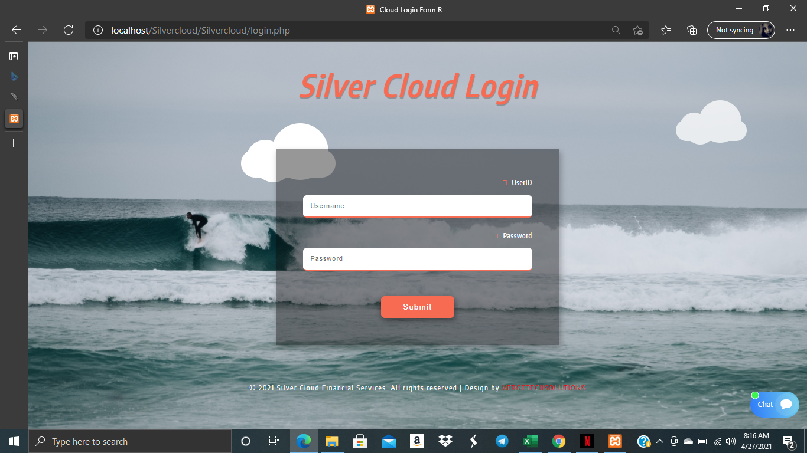

*Fig 1.0*

*Incorrect Login Credentials Error Message*

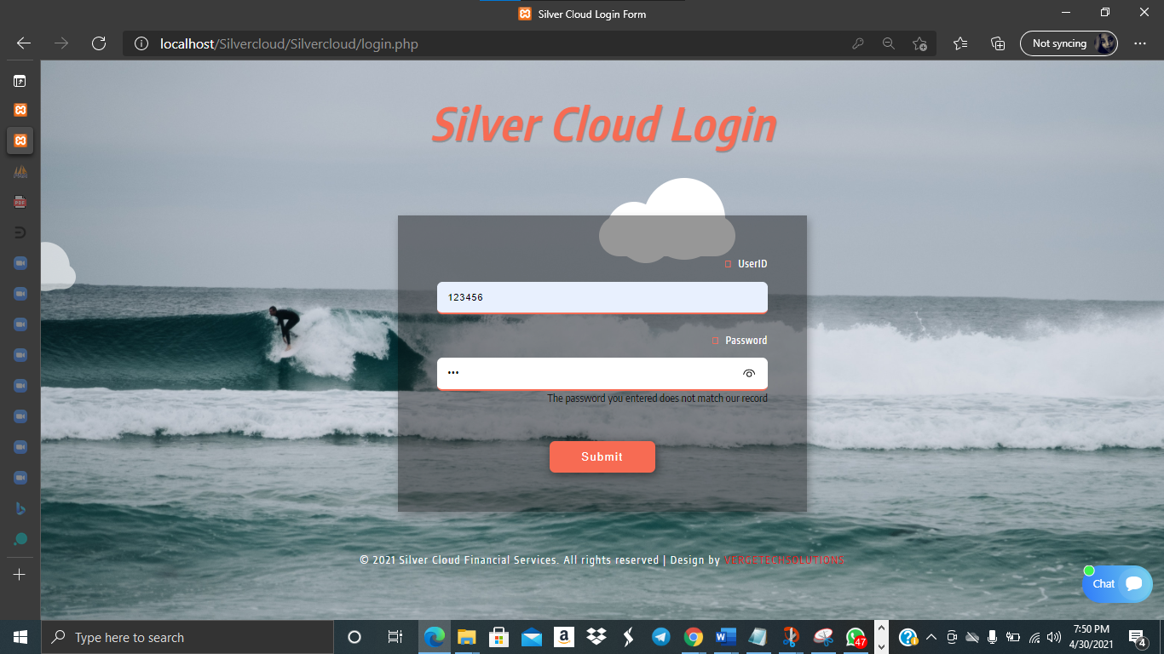

### 5.1.2 Silver Cloud Client Registration Form

The below registration form is completed by Branch Managers on behalf of their clients in order to create/open their account with the company

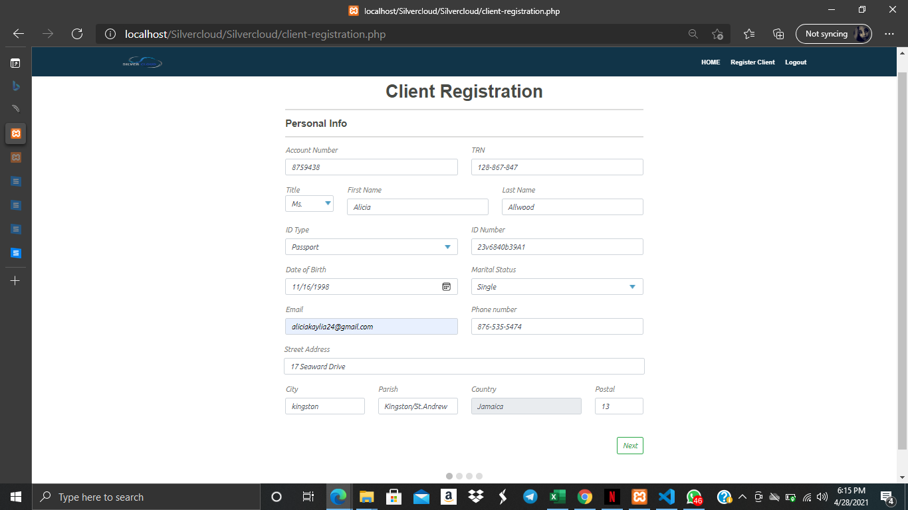

Fig 2.0

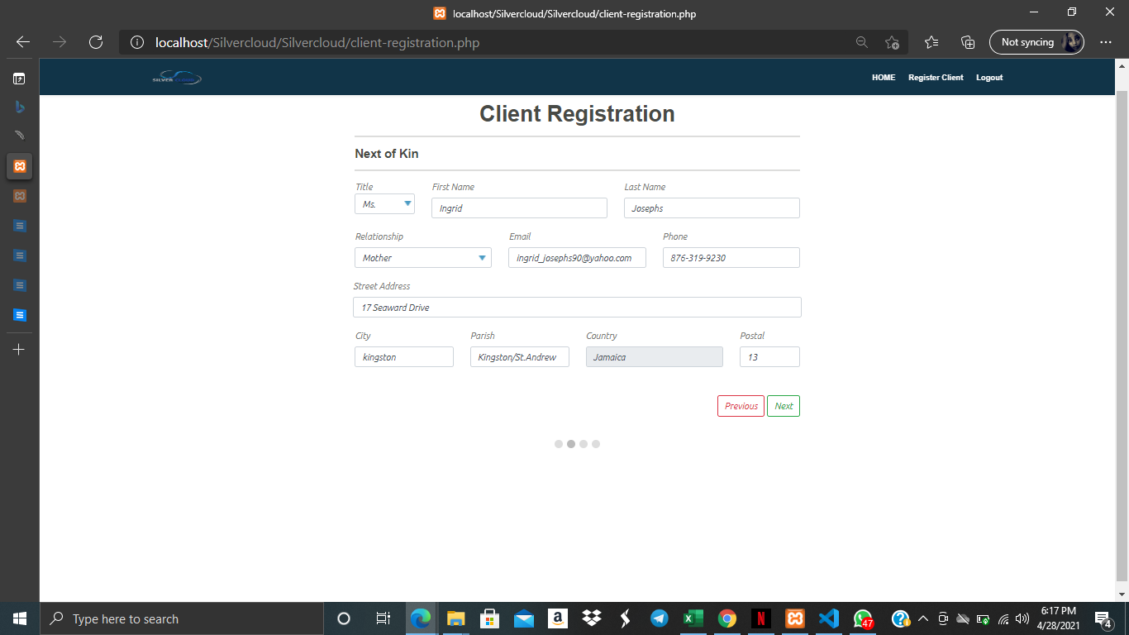

Fig 2.1

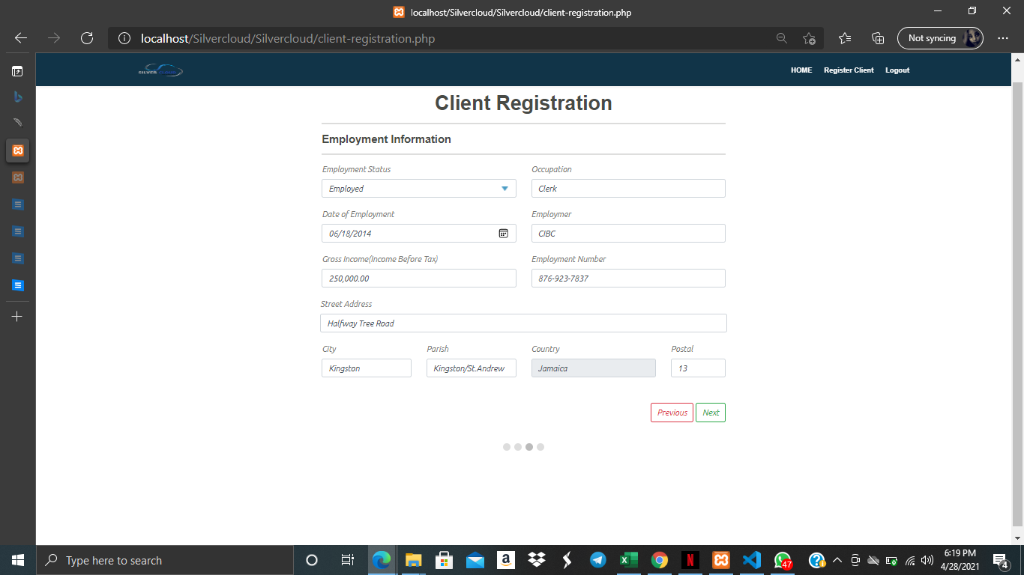

Fig 2.2

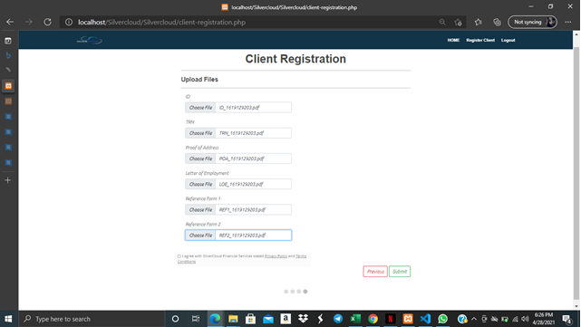

Fig 2.3

### 5.2 Silver Cloud Client Loan Application Form

The below loan application form is completed by Silver Cloud Clients

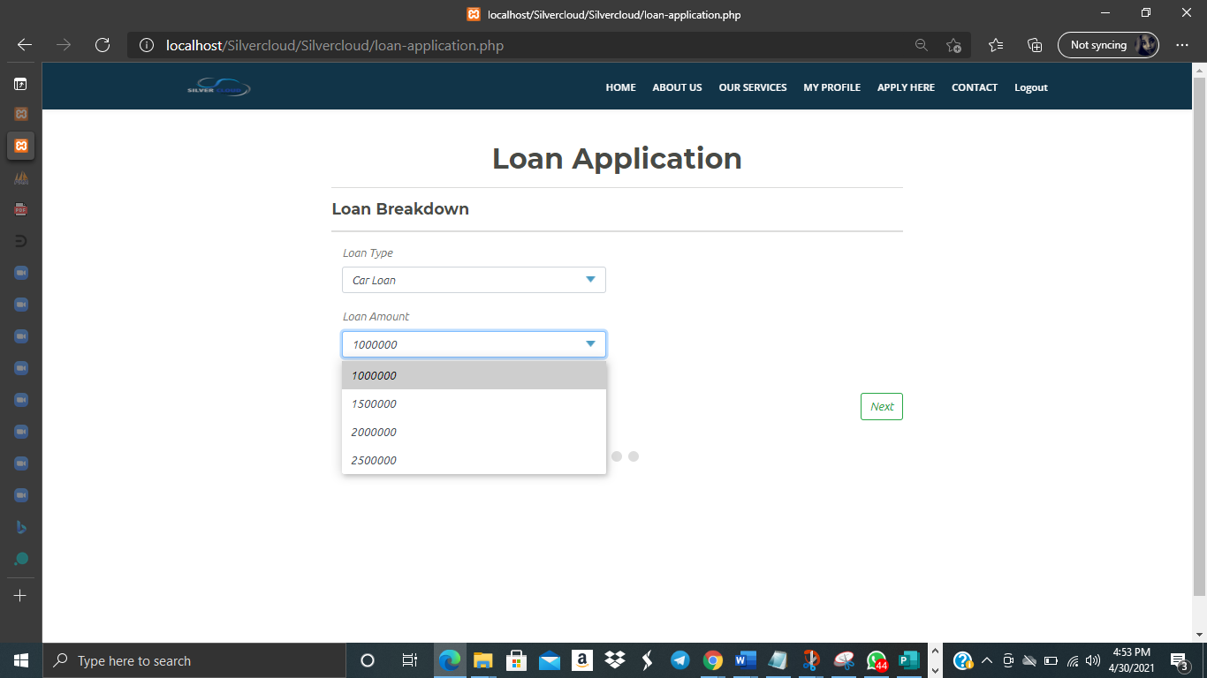

Fig 2.4

Silver Cloud Loan Application Form Cont’d - Income and Expenditure

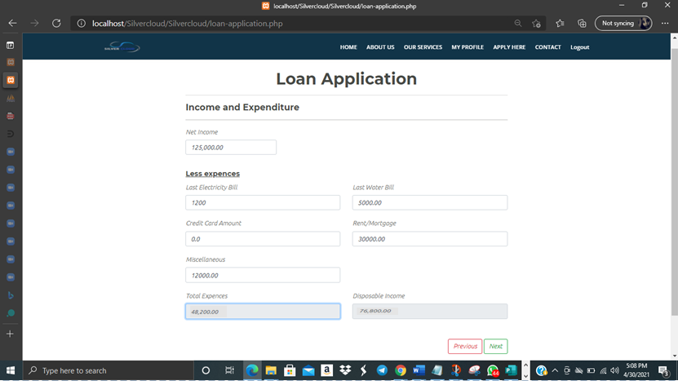

Fig 2.5

Silver Cloud Loan Application Form Cont’d - Upload Files

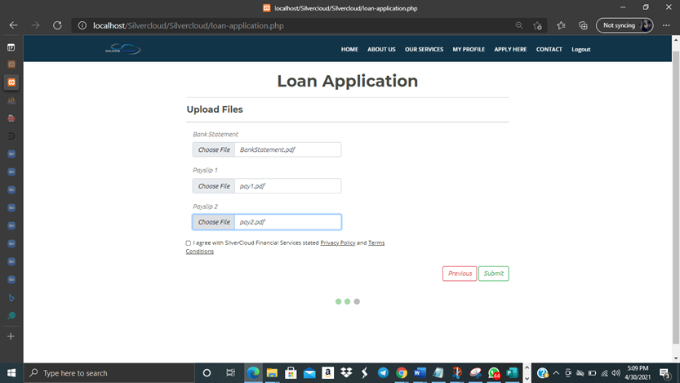Fig 2.6

Loan Application Submission Success Page

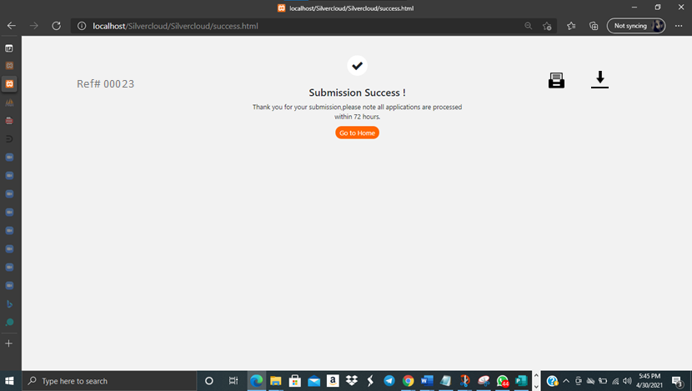

Fig 2.7

### 

### 5.1.2 Silver Cloud Loan Application Approval/Decline Process

The below displays how the Branch Managers Approve or Decline Loan Applications

Home Screen for Branch Managers - Displays Listed Applications

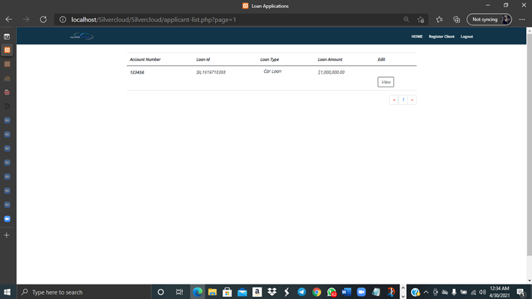

Fig 2.8

The below shows the full form of the above viewed by Branch Managers in order to Accept/Decline Loans by criterias.

Personal Information Section

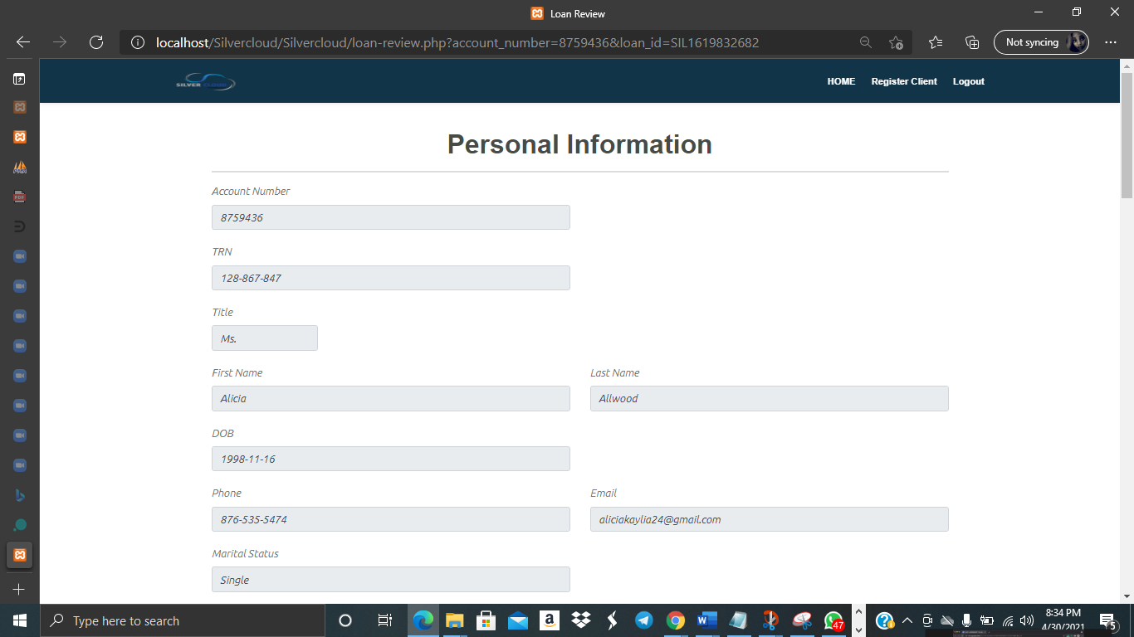

Figure 2.9

Next of Kin Section

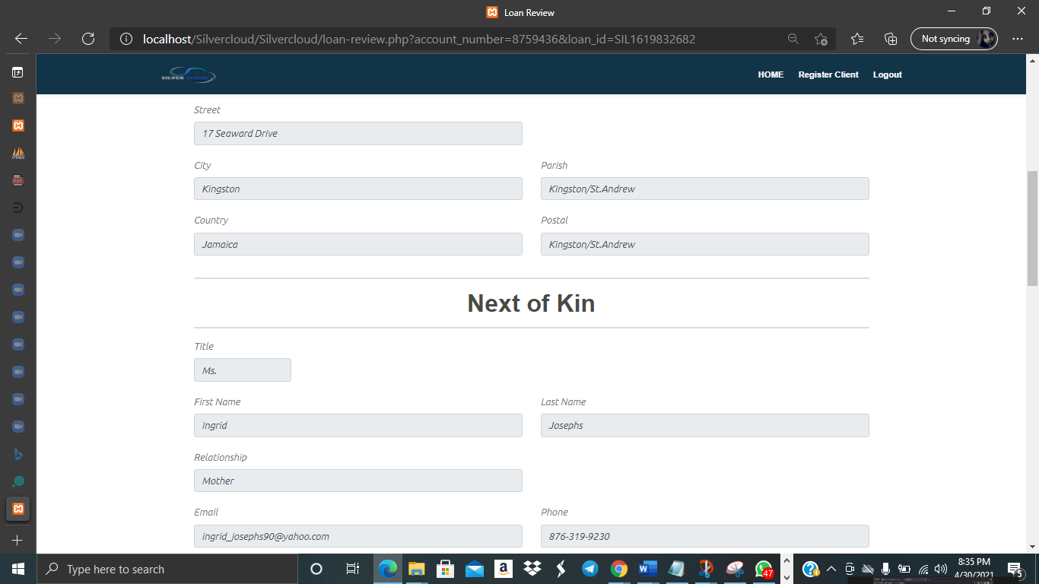

Fig 3.0

Employment Information Section

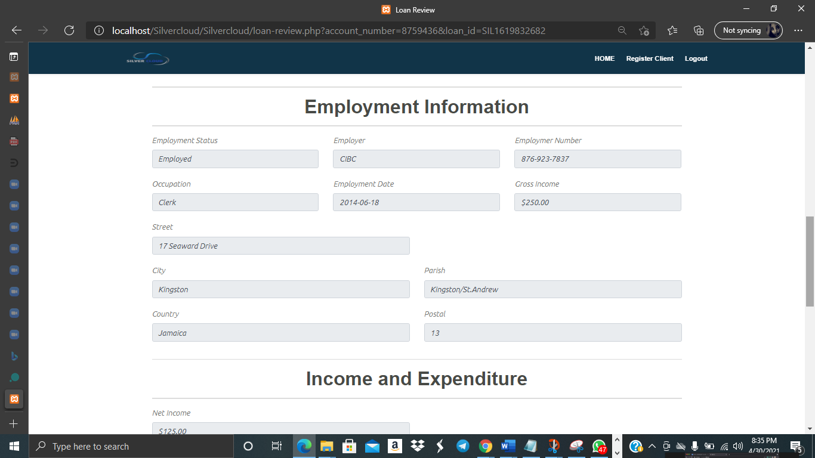

Fig 3.1

Income and Expenditure Section

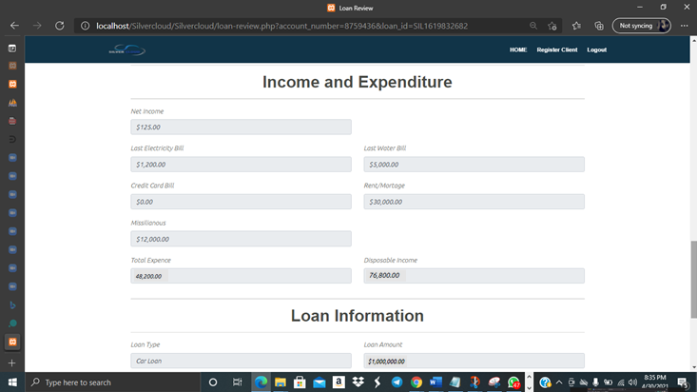

Figure 3.2

Section to view Loan Information where Credit Score is auto-calculated, to Accept/Decline Application and also to view applicant uploaded files

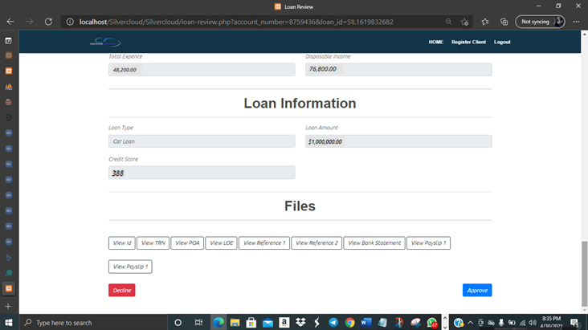

Fig 3.3

Downloadable Files

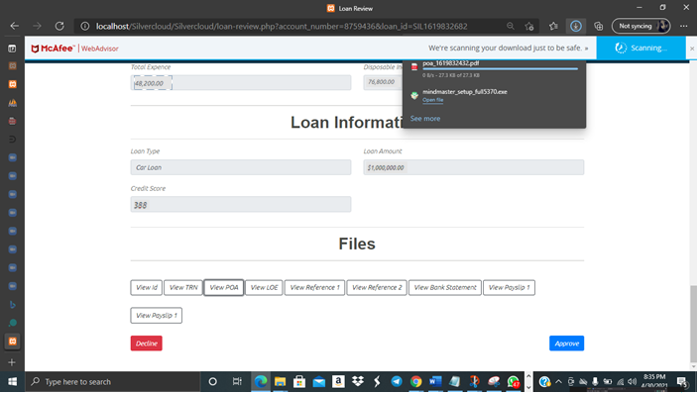Figure 3.4

Client Slide

Section for Client to View Status of Loan

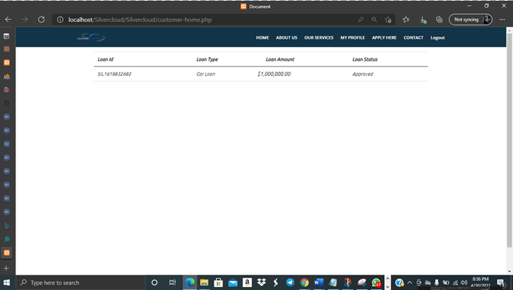

Figure 3.5

Client Slide - View and Edit their Profile

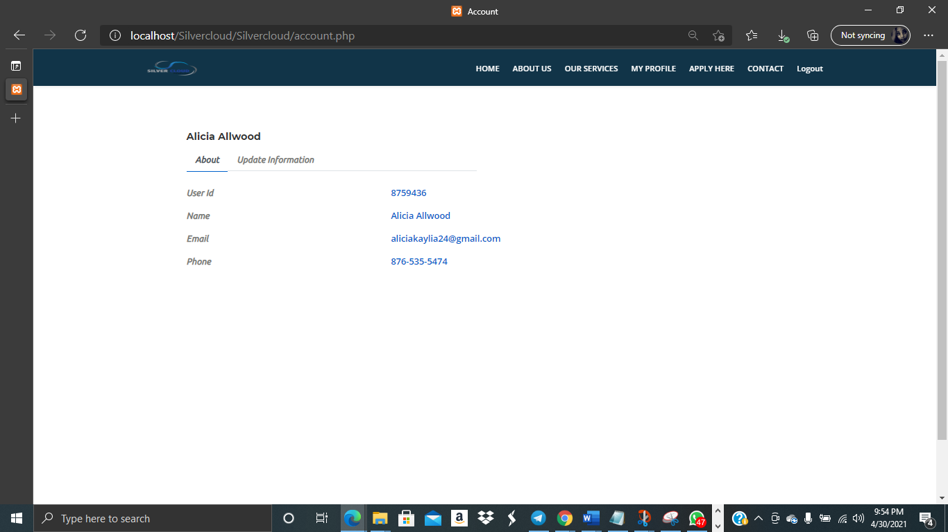

Figure 3.6

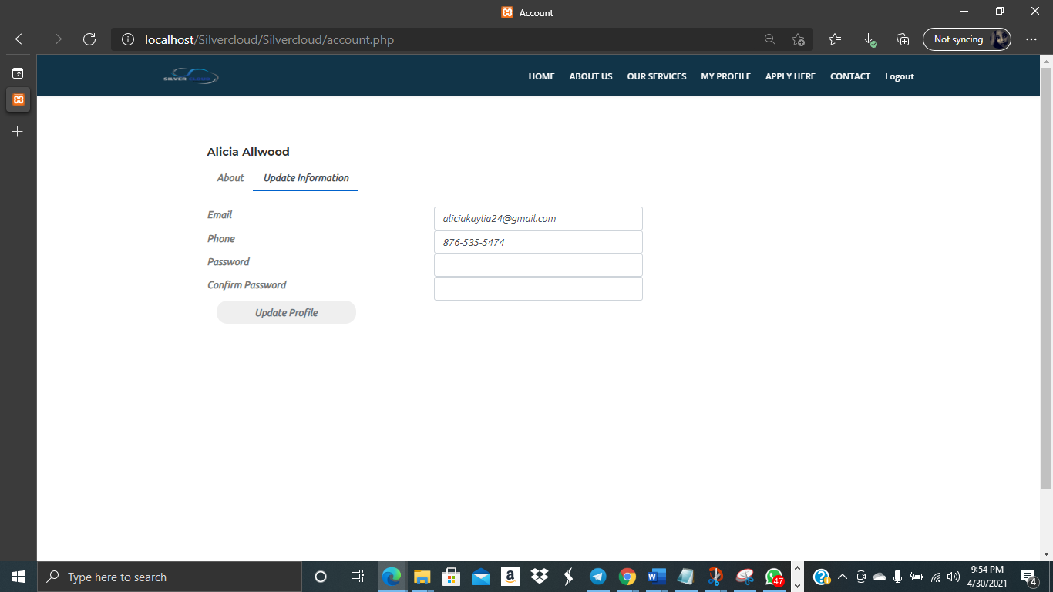

Fig 3.7

## 5.3 System interfaces, menu & control

Index/Main Screens

## 

Figure 4.0

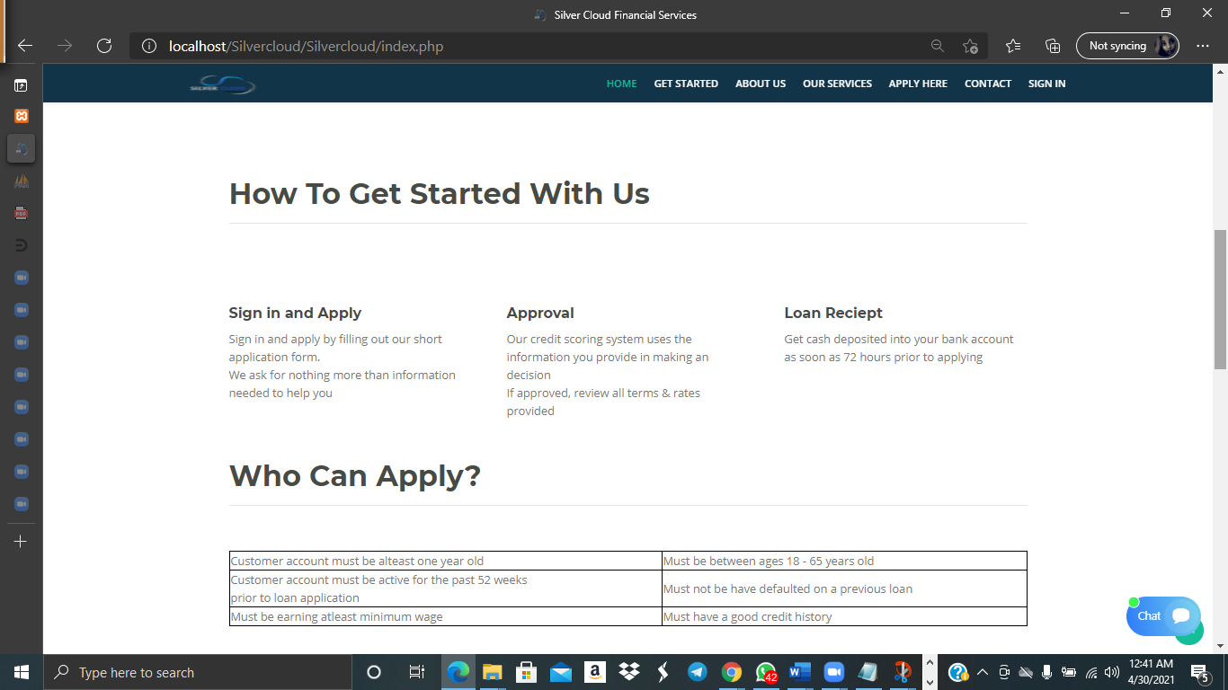

Figure 4.1

Customer Testimonials

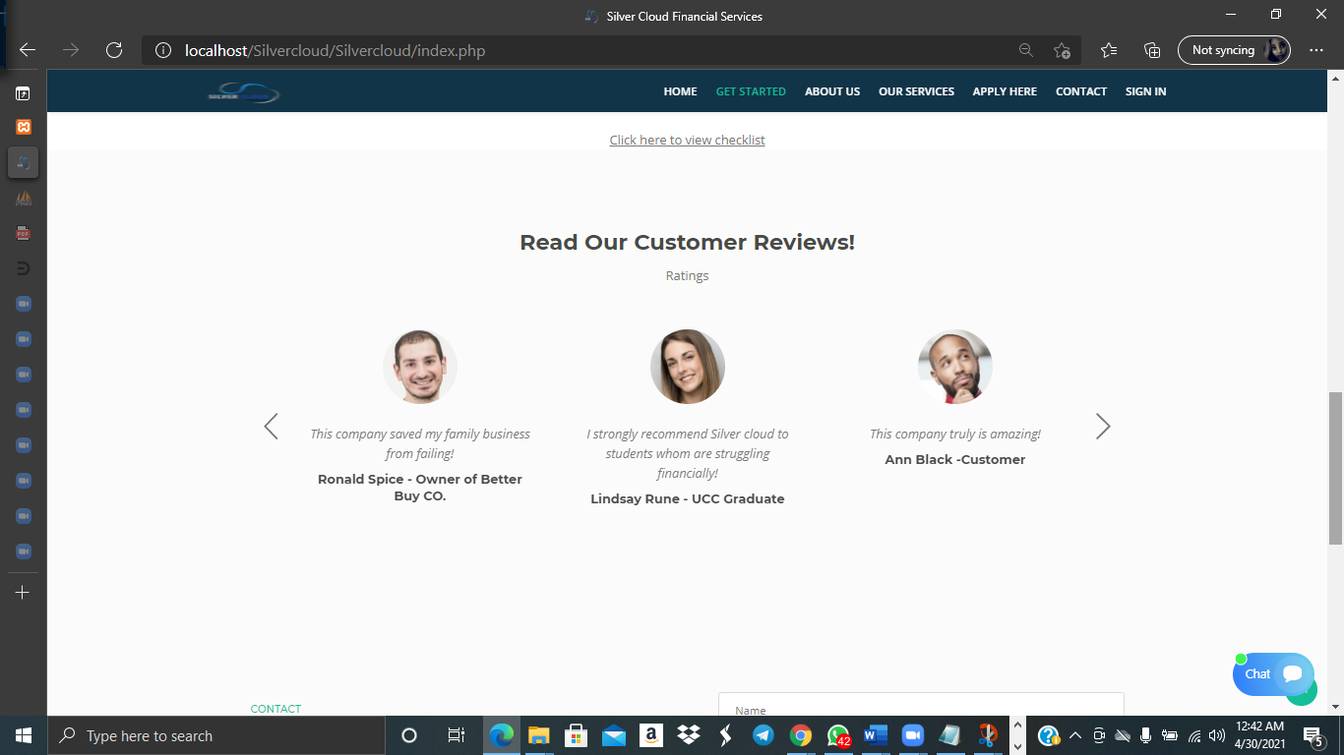

Figure 4.2

**Loan Checklist of Required Documents**

## 

Figure 4.3

**Direct Contact Form and Footer**

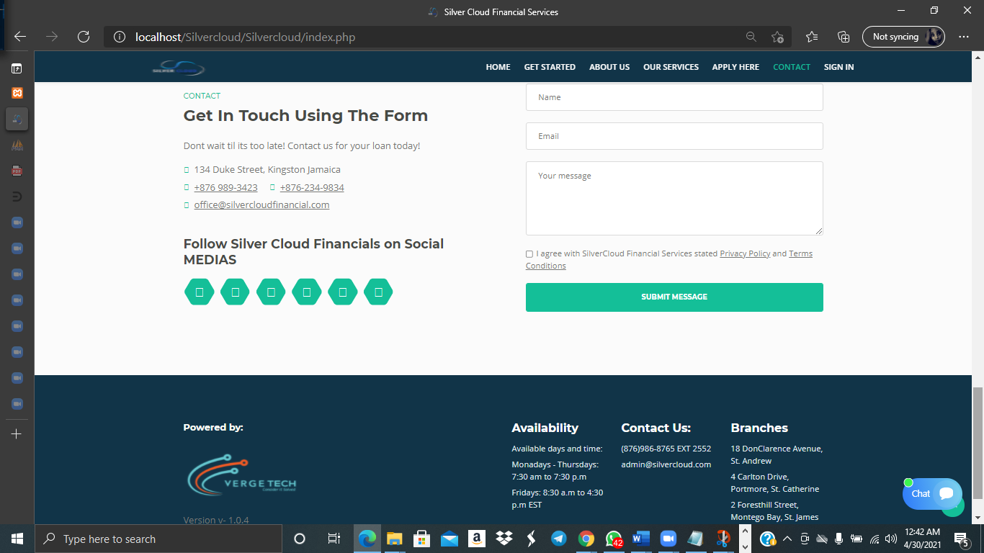

Figure 4.4

**Live Chat System**

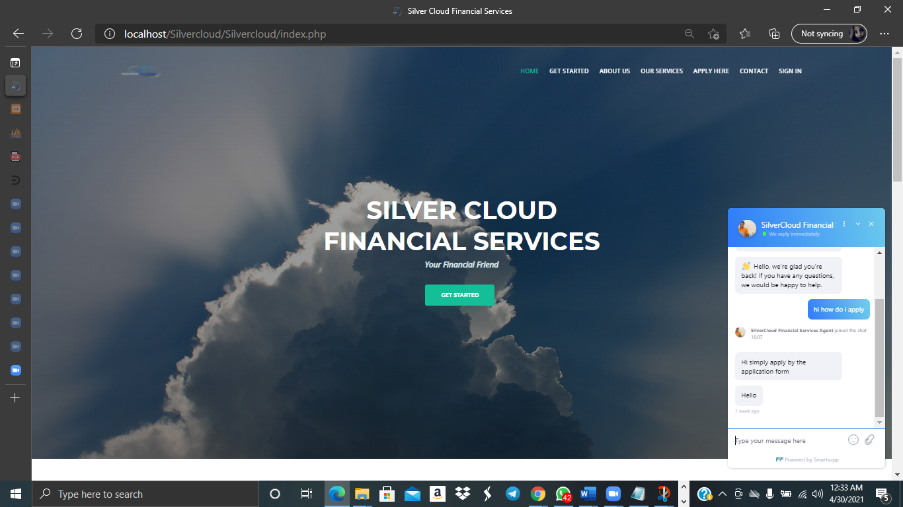

Figure 4.5

**About Us Screens**



Figure 4.6

**About Us Cont’d**



Figure 4.7

**Our Services Screens**

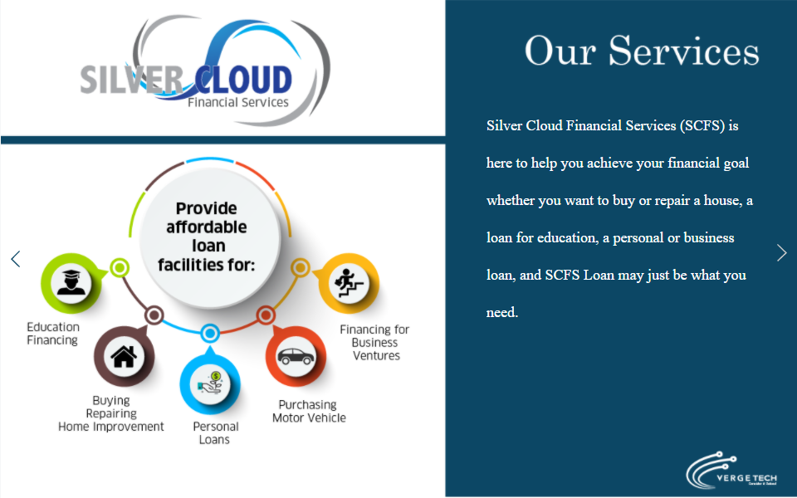

Figure 4.8

**Our Services cont’d - Car Loan**



Figure 4.9

**Our Services Cont’d - Personal Loan**



Figure 5.0

**Our Services Cont’d - Education Loan**



Figure 5.1

**Our Services Cont’d - Business Loan**



Figure 5.2

**Our Services Cont’d - Mortgage Loan (Buy)**



Figure 5.3

**Our Services Cont’d - Mortgage Loan (Repair/Improve)**



Figure 5.4

## 5.4 Proposed architecture (data distribution, network layout, etc.)

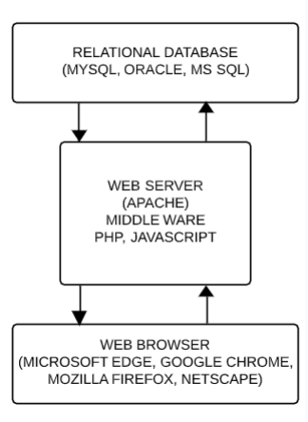

Fig 5: Architecture of OLASS Web Application

* **Network Layout**

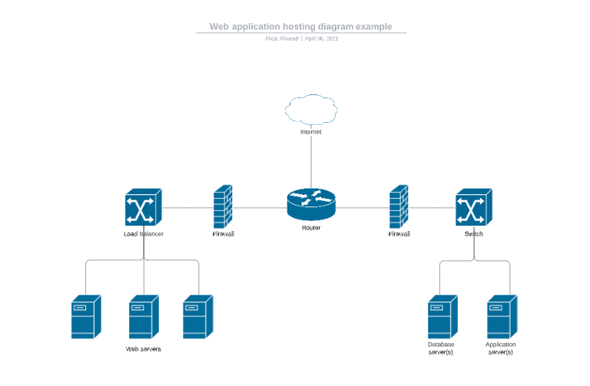

## 

## 5.5 Proposed platform (memory, disk space, operating system, peripherals, network, etc)

**HARDWARE & SOFTWARE REQUIREMENTS**

* The minimum requirements of hardware and software for running the web application is as follows.
* **MINIMUM HARDWARE REQUIREMENT**
* **Server Slide**

|  |  |
| --- | --- |
| **Processor** | **2.4GHz** |
| **Hard Disk** | **40 GB Free Space** |
| **RAM** | **2 GB** |

* **Client Slide**

|  |  |
| --- | --- |
| **Processor** | **1.9 GHz** |
| **Hard Disk** | **20 GB Free Space** |
| **RAM** | **1 GB** |

* **MINIMUM SOFTWARE REQUIREMENT**
* **Server Slide**

|  |  |
| --- | --- |
| **Operating System** | **Windows Server 2012** |
| **Web Server** | **Apache Tomcat version 7** |
| **Front-End Tools** | **Java/jdk 1.6.0 (JSP/Servlet)** |
| **Back-End Tools** | **PHP MYADMIN MYSQL Server v3.2** |

# 

# Client Slide

|  |  |
| --- | --- |
| **Operating System** | Windows or any compatible OS |
| **Web Browser** | Microsoft Edge, Google Chrome or any compatible browser |

# 

# 7. IMPLEMENTATION

## 7.1 Implementation plan (implementation method, schedule, data loading, training)

With the implementation of a new online application system by Silver Cloud Financial Services (SCFS), Verge Tech recommends the Direct Changeover method for implementation of the online system, which would allow for a seamless transition.

Although there are several types of implementation methods, the Direct Changeover is the most suitable method to implement the Online Loan Application Selection System (OLASS), as there are minimal changes, the system is not too complex and does not require any data migration. Based on the delivery timelime the system is scheduled to go live on September 26, 2022. Also, this method proves to be less costly as there are specific timelines in place to prevent a cost overrun.

Though OLASS is a web based application system which may be stored on the company’s server for real time access/transactions in all three (3) locations, the implementation process will still posed some challenges such as:

1. The users will need to operate as if it is business as usual while learning the new system, as they would not be able to revert to the old system
2. The lack of support beyond the implementation phase
3. System downtime
4. User device not compatible with the new system

The Direct Changeover method also has advantages and disadvantages to consider when used implementing a new system:

Advantages

* A cheap method of changeover
* Takes the minimal time and effort to switch from the old system to the new system
* The new system is up and running immediately
* Less change of the new system being faulty, as it would have been fully tested before implementation

Disadvantages

* If the new system fails, there is no back-up system, so data can be lost
* Staff would have to be fully trained and ready ready to use the new system before it is implemented

|  |  |  |  |  |
| --- | --- | --- | --- | --- |
| **Risk** | **Rating** | **Contributing Factor** | **Impact** | **Control** |
| **Stakeholder Management (Internal):**  Dissatisfied employees might deliberately modify or destroy information in the system | Medium | Institute access level profiles and limit interaction with the system where necessary | Customer information disseminated in the public domain | Conduct periodic audits of the system |
| **System Risk**    Delays preparing selection reports due to system downtime | Medium | System unreliability    System malfunctioning or require updating | Inability to produce complete, timely and accurate reports | Periodic performance audits    Escalate issues identified to IS/web developer |
| **System Risk**  A hacker or industrial spy might break into the system | Medium | System not fully protect | Customer personal/account information disseminated in the public domain | Conduct periodic audits of the system    Escalate issues identified to IS/web developer |
| **System Risk**  Viruses or malicious software could be introduced | Medium | System not protect from malicious software | Customer information/records destroyed | Conduct periodic audits of the system    Escalate issues identified to IS/web developer |
| **System Risk**  Accidental mistakes could be made on input to the system | Medium | Customer declaring/inputting wrong information | Wrong selection | Conduct periodic audits of the system    Develop system validation functions |

The Online Loan Application System project is estimated to last approximately 16 months. The cost of the project is estimated at $5,500,000.00, broken down as under:

|  |  |  |  |
| --- | --- | --- | --- |
| Project Deliverable | Responsible Officer | Timeline | Estimated Cost |
| Planning Phase | Project Manager | June 1, 2021 to July 23, 2021  (8 weeks) | - |
| Develop phase implementation schedule | Project Manager | July 26, 2021 to August 6, 2021  (2 weeks) | $250,000,00 |
| Define System Requirement and acquire resource | Systems Analyst | August 9, 2021 to September 3, 2021  (4 weeks) | - |
| Develop new system to accept loan applications online | IS Team/Consultant/  Developer/Programmer | September 6, 2021 to April 15, 2022  (32 weeks) | $4,000,000.00 |
| Rollout user-acceptance testing | Internal Staff | April 18, 2022 to July 22, 2022  (14 weeks) | $750,000.00 |
| Training for Staff | Project Manager/ HRM | July 25, 2022 to September 23, 2022  (9 weeks)  Schedule:  **St Andrew Branch**  July 25 to August 12, 2022  **Portmore Branch**  August 15 to September 2, 2022  **St James Branch**  September 5 to September 23, 2022 | $500,000.00 |
| Date of Implementation | Project Manager | September 26, 2022 | - |
| Total Estimated Cost | | | $5,500,000.00 |

**Testing**

# 

|  |  |  |  |  |  |
| --- | --- | --- | --- | --- | --- |
| No | Test Cases | Case Type | Expected Result | Actual Result | Pass/Fail |
| 1 | Admin Login | 1.Wrong User Name And Password | The system displays an Error Message, prevents from Login. | The system displays an Error Message “Invalid User Name or Password”, prevents fromLogin. | Pass |
| 2. Enter Correct User Name And Password | The system updates Session variables and redirect to home page. | The System Display Home Page for User/Admin. | Pass |
| 2 | Admin | 1. Company Admin | The System can Redirect the Page. | The System Display All Pages for Admin. | Pass |
| 2. User Detail | The System can Redirect the Page. | The System display to the all user details. | Pass |
| 3. User Type Master | The System can Redirect the Page. | The System display to the all user type master | Pass |

# 

|  |  |  |  |  |  |
| --- | --- | --- | --- | --- | --- |
| No | Test Cases | Case Type | Expected Result | Actual Result | Pass/Fail |
| 5 | Customer Login | 1. Non-Registered User | The System will not allow Non Registered User to Login. | Non-Registered user can not Login. | Fail |
| 2.Wrong User Name And Password | The system displays an Error Message, prevents from Login. | The system displays an Error Message “Invalid User Name or Password”, prevents fromLogin. | Pass |
| 3. Enter Correct User Name And Password | The system updates Session variables and redirect to home page. | The System Display Home Page for User/Customer. | Pass |
| 6 | Customer Registration | Enter null in mandatory fields | It will not add the detail | It will show message that enter the data. | Pass |
| Enter incorrect data | It should not let add the Enter Product. | It will show message that enter the correct data. | Pass |
| Enter correct data of all required field | It should let add the Enter Correct Detail . | It will show the message of Add Detail. | Pass |
| 8 | Loan Details | Enter customer loan details. | There will not add other detail. | There will provide customer ‘s loan details. | Pass |
| 9 | EMI details | Enter loan amount + Tenure+ rate . | There will not add other detail. | There will provide all calculated EMI details . And also it can be store | Pass |
| 10 | Receive payment details | Enter customer’s receive EMI payment details. | There will not add other detail. | There will provide customer receive payment details. | Pass |

# APPENDICES

## Project team structure and responsibilities

**Project Sponsor**

Responsibilities

* Create overall project vision
* Make key decisions within the project
* Approve budget and changes
* Take inventory of project resources

**Implementation Manager**

responsibilities:

* Manage components of the plan
* Delegate tasks to key team members
* Create a project schedule
* Lead team members through each phase
* Communicate to team members and senior management

**System Analyst**

responsibilities:

* Analyze and create tests
* Develop specifications and requirements for developers and programmers to follow
* Develop user manual for the system
* Perform training for end users

**Network Administrator**

responsibilities:

* Designing and planning the network
* Setting up and maintenance of the network
* Expanding the network
* Train team members

**Software Developer**

responsibilities:

* Taking through requirements with clients
* Testing software and fixing problems
* Maintaining systems once they’re up and running
* Being a part of technical designing
* Integrate software components
* Producing efficient codes
* Writing program codes for reference and reporting

**System Tester**

responsibilities:

* Identifying the Target Test Items to be evaluated by the test effort
* Defining the appropriate tests required and any associated Test Data
* Gathering and managing the Test Data
* Evaluating the outcome of each test cycle

**User Acceptance Tester**

responsibilities:

* Oversee acceptance testing
* Design, develop and maintain test plans and test cases
* Ensure comprehensive planning and design that map to all product requirements as well as software requirements
* Conduct UAT test plan walkthrough meetings and obtain sign off
* Maintain appropriate UAT documentation
* Provide mentorship to testers to improve quality of UAT test plan and test cases

**Network Technician**

responsibilities:

* Install operating system
* Assess and identify issues with PCs and laptops
* Install and maintain network cabling
* Troubleshoot issues with computer and network

**Diagrams**

**Customer Use Case Diagram**

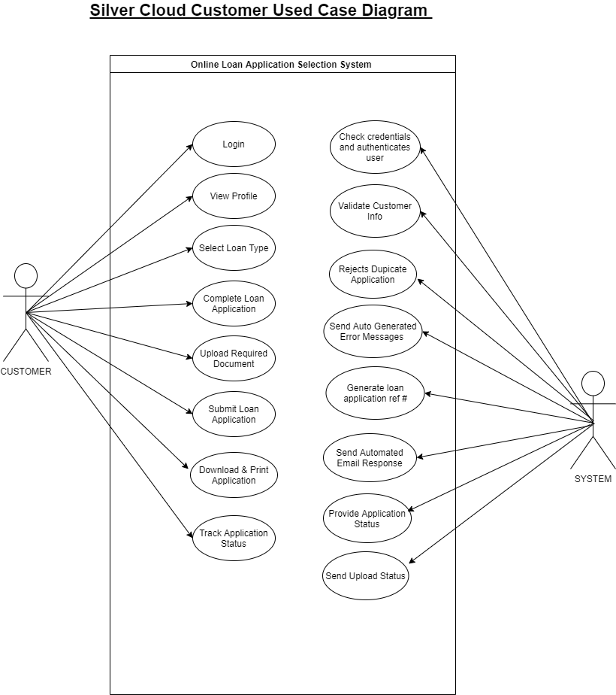

**Staff use Case Diagram**

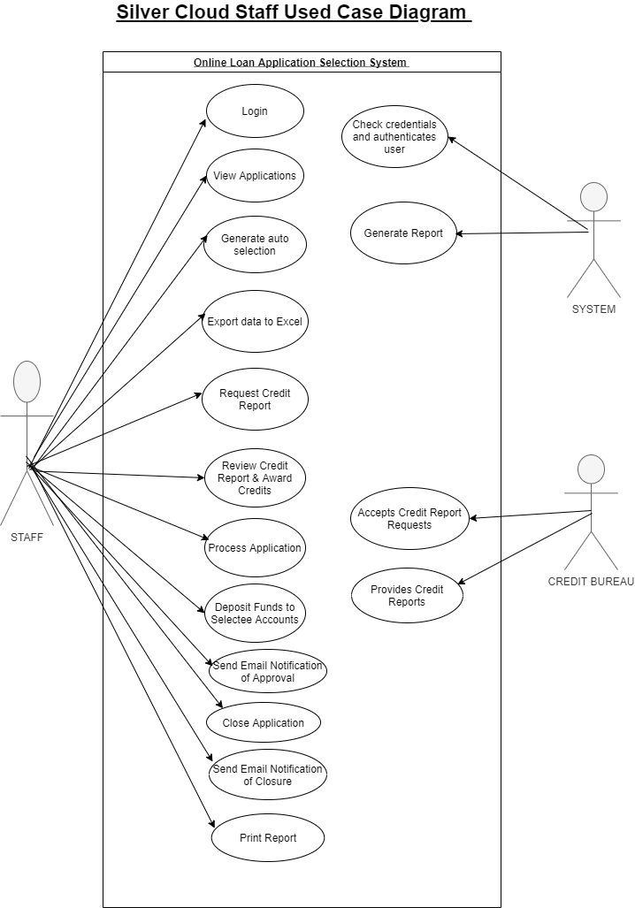

**Context Diagram (Level 0)**

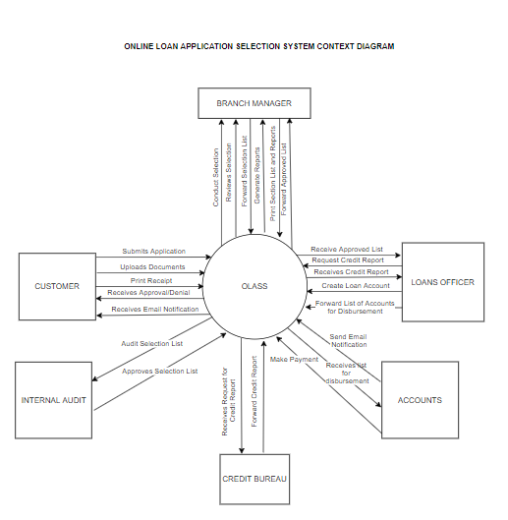

**Context Diagram (Level 1)**

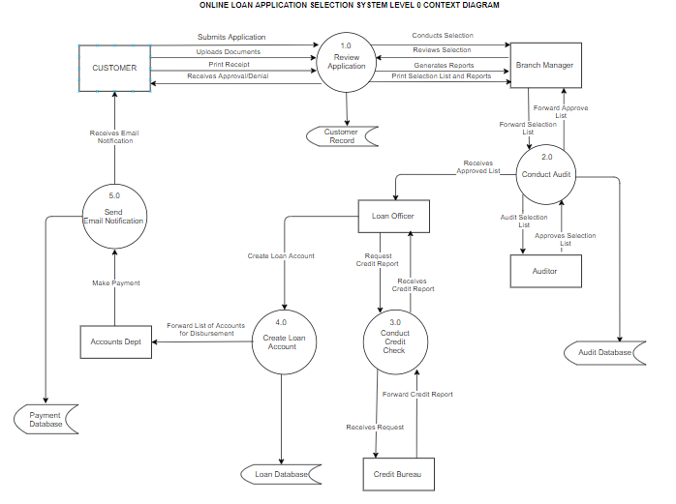

**Entity Relation Diagram**

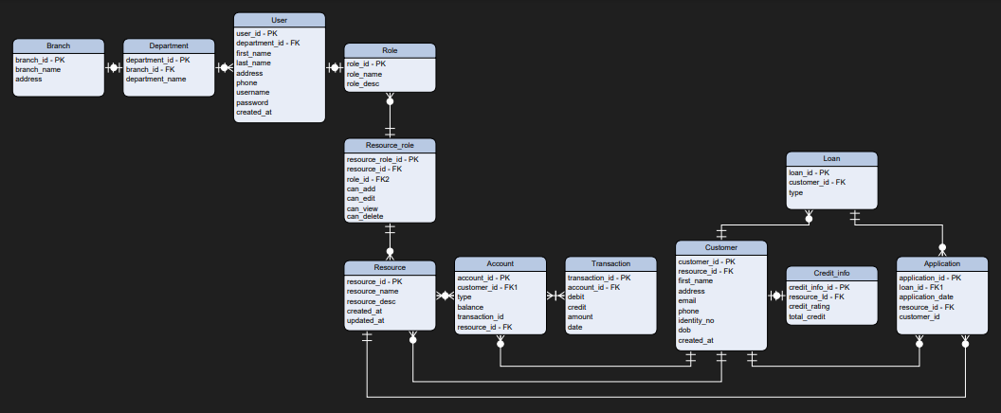

## APA Referencing

Christiawan, Evan. (2016). Comparative Assessment of Custom developed and packaged

software in accomplishing Business's Objective.

IGCSE ICT - Implementing a System. (n.d.). https://www.ictlounge.com/html/implementation.htm.

Parafianowicz, K. (2020, October 6). *Software Development Team Roles and Responsibilities*

*You Should Know*. SoftwareHut. https://softwarehut.com/blog/it-outsourcing/software  
  
 -development-team-roles-and-responsibilities.

Project Team MemberRoles and Responsibilities. Project Team Roles and Responsibilities |

Hubstaff Tasks. (n.d.). https://hubstaff.com/tasks/project-team-roles-responsibilities.

Technojobs Ltd. (n.d.). *The Role of a Software Developer*. TechnoJobs. https://www.tec

hnojobs.co.uk/info/developer-guides/the-role-of-a-software-developer.phtml.

## Conclusion

Silver Cloud Financial Services was experiencing challenges with its core business operation that provides its customers with an effective and seamless loan process. As such verge tech was contracted to develop an Online Loan application selection system (OLASS) which in return will eliminate manual processes, improve efficiency and save time. The system is slated to commence in June 2021 and projected completion date of september 2022.

The direct changeover method will be used to implement the online application system as this is more cost effective as the system would have been fully tested before implementation and less complex as data migration is not required.